Core Highways Release Notes v4.2.0.0

Table of Contents
1 Document Control 4
1.1 Author 4
1.2 Document Summary 4
1.3 Document History 4
1.4 Reference documents 4
1.5 Distribution 4
1.6 Quality Assurance 4
2 Introduction 5
3 4.1.0.1 Log No. Summary 6
3.1 ECDM Log 722009 Bulk Merge Failure 6
3.2 Task 0108687 – Primary Key Violation on creation of Asset 6
3.3 Task 0108681 - Displaying Partial Group Membership 7
3.4 Task 0108660 Hierarchical Assets 7
3.5 ECDM Log 722941 - Derived asset TSTR fails 7
3.6 ECDM Log 723304 - Unable to create spatial element 7
3.7 ECDM Log 722923 - GOS and splitting element 8
3.8 ECDM Log 723234 – Negative Route Measures 8
3.9 ECDM Log 723017 - MQ returns invalid dates for 1950 and prior 8
3.10 ECDM Log 723001 - Merge of Datums with Partial Groups 8
3.11 Task 0108592 – Merge Query Issue String buffer too small. 8
3.12 Task 0108567 – Network groupings 9
3.13 Task 0108565 – Locator Unpin Problem 9
3.14 ECDM Log – 720290 – Admin Unit Security and Date Logic 9
3.15 Task 0108559 – Highlight Colour in Spatial Manager 9
3.16 Task 0108558 – Redundant layer Creation Buttons 9
3.17 ECDM Log 723068 – Locator Map measure tool failure 9
3.18 ECDM Log 722085 - Error creating a defect on asset 9
3.19 Task 0108516 – GRI0200 and PL/SQL numeric or value error 10
3.20 ECDM Log 714261 - Error modifying colours in STP4400 10
3.21 ECDM Log 723431 – Error in snapping Defects to Road Network in Locator 10
3.22 Task 0108755 – Off-network Asset Attributes in SM 10
3.23 ECDM Log 723610 - Display of USRN no in Datum Elements 11
3.24 ECDM Log 722924 – Resize Route Not Working 11
3.25 Task 010866 – Validation of Decimal Places on Asset Attributes 11
3.26 Task 0108833 - SM - X and Y attribute Values Rounded 11
3.27 Task 0108836 – Unable to Create Datum Element in Spatial Manager 11
3.28 Task 0108874 – reshaped polygons or lines disappear or degenerate to a point 11
3.29 Task 0108887 - Get From Map not working at 4100 12
4 Known Issues at 4.1.0.1 13
4.1 Creation of a user 13
4.2 Number formats in SM 13
4.3 Failure in creation of an off-network asset layer 13
5 Fixes, Enhancements and Changes at 4.2.0.0 14
5.1 Task 0108242 - Mixed Case Asset Attributes 14
5.2 Task 0107356 - Forms crash on exiting a form with error FRM-92100 15
5.3 Task 0108740 - Multiple themes results in Hig-0150: GIS Theme data is invalid. 15
5.4 Task 0108386 - Locator searches with Null and Not Null predicates 15
5.5 Task 0108620 - Resize group is prevented when inappropriate 15
5.6 Task 0108765 - Rounding of decimal places in numeric attributes 15
5.7 Task 0108705 - Un-end-dating an asset 15
5.8 Tasks 0108731 and 0108757 – Historical spatial data 15
5.9 Task 0108789 – HIG_USER Role is mandatory 15
5.10 Task 0103787 – query in NM0590 results in FRM-40831: 16
5.11 Task 0108303 – Analyze Any Privilege 16
5.12 Task 0108723 – refresh NSG spatial Layers 16
5.13 Task 0108701 Unhandled exception ORA-20060 16
5.14 Task 0108674 – Use of public synonym to Spatial metadata 16
5.15 Task 0108566 – Removal of theme creation from forms 16
5.16 Task 0108555 – HIG.PLL ordering utilities 16
5.17 Task 0108549 – Highways owner integrity check 16
5.18 Task 0108543 – calling Gazetteer results in ORA-6502 16
5.19 Task 0108524 – Impact of column change to NE_DESCR to 254 characters 17
5.20 Task 0108957 – Correction to Theme Metadata 17
5.21 Task 0108915 – Move of a generic package from the MCI product into core 17
5.22 Task 0108890 – Asset view creation during creation of Off-network-asset layers 17
5.23 Task 0108821 - FRM40202 Field must be entered in NM0510 17
5.24 Task 0108817 – Incorrect version tag reported in form NM0530 17
5.25 Task 0108815 – Error NET-0389 Invalid value…. 17
5.26 Task 0108802 – Resize route button is greyed out. 17
5.27 Task 0108477 – Web utilities 17
5.28 Task 0108354 – Module HIG1901 has increased size of Username in LOV 17
5.29 Task 0108212 – Use of CTRL-Q to cancel query in NM0510 17
6 Addendum to pre-release document version 1.0 18
6.1 Task 0108209 – Errors with effective data in NM0560 18
6.2 Task 0108283 – Order of defects created in Locator. 18
6.3 Task 0108568 – Displayed Units in MapViewer 18
6.4 Task 0108908 – Intersection Modelling 18

- Document Control
- Author
Rob Coupe, Technical Architect
- Document Summary
This document provides a description of the changes in this release and information about how these changes may impact on an Exor installation.
- Document History

Document History
Revision | Date | By | Description
1.0 | 17th December 2009 | R Coupe | Pre-release Edition
1.1 | 19th January 2009 | R Coupe | Post-build changes
- Reference documents
None

- Distribution
Exor Customers, Partners and Staff

- Quality Assurance
Document Details
File | Prepared By
0000.doc | Rob Coupe
Document Name | Reviewed By
Core Highways Release Notes
Version | Approved for issue by
1.0
Date of Issue | Support Manager

- Introduction
This document highlights the key changes to the exor Core Highways database following the release of Core Highways v4.2.0.0. It is specifically targeted at users and system administrators of the exor systems. Changes in the core database functionality have the potential to have wide impact across all exor applications and it is important that these changes are understood. However, many of the functions of exor Core Highways are extremely technical in nature and this document is aimed at those with some degree of technical knowledge and not necessarily at end users.

It is not intended to be a full system description but a guide to indicate what changes have been made, why they have been made and the potential failings if this upgrade is not applied.

This release is available as an upgrade from release 4.1.0.0 and 4.1.0.1. of exor Core Highways.

After reading through this document, should you have any need for training or consultancy then please contact your exor account manager. If these changes are considered important for your current release and this is incompatible with this patch release then please contact exor support.

This release is intended to be used in conjunction with a version of Spatial Manager that includes changes to support mixed case attributes and BS-7666 changes to the NSG modules. The version/build number will be reset to be 4.2.0.0 to be compatible with the core major release numbers. All matters relating to support for NSG within Spatial Manager will nto be reported in these release notes as it forms part of the NSG release.

The releases of core have been steadily improved with bug fixes having been applied to several fix releases after the cut-off date for 4.1.0.0. This meant that the 4.1.0.1 release was required to enable some customers to move up without loss of functionality. The release notes for 4.1.0.1 also contained some known issues and some of these have been dealt with during the 4.2.0.0 development. Since 4.2.0.0 may be applied from a 4.1.0.0 or a 4.1.0.1 release, this document is split into 3 sections that cover the 4.1.0.1, known issues at 4.1.0.1 and the 4.2.0.0 release. The release notes were published as a pre-release at version 1.0. This was made available to interested parties. The list of tasks and ecdm logs that have been completed in the 4.2.0.0 release of exor Core Highways has grown significantly since that pre-release version of the notes. However, several of the issues intended for this release have been moved and will be included in the considerations for the next release. These are listed in the final section.

The next release notes will provide details of tasks and ecdm numbers in a tabulated form as an extract from the ecdm task monitoring system.
- 4.1.0.1 Log No. Summary
This chapter summarises all Software Bugs and Changes that have been made in the 4.1.0.1 release. There follows a set of proposed fixes and enhancements that will be available in the 4.2.0.0 release.

- ECDM Log 722009 Bulk Merge Failure
Failure of the execution of a bulk merge query at a past historic date.

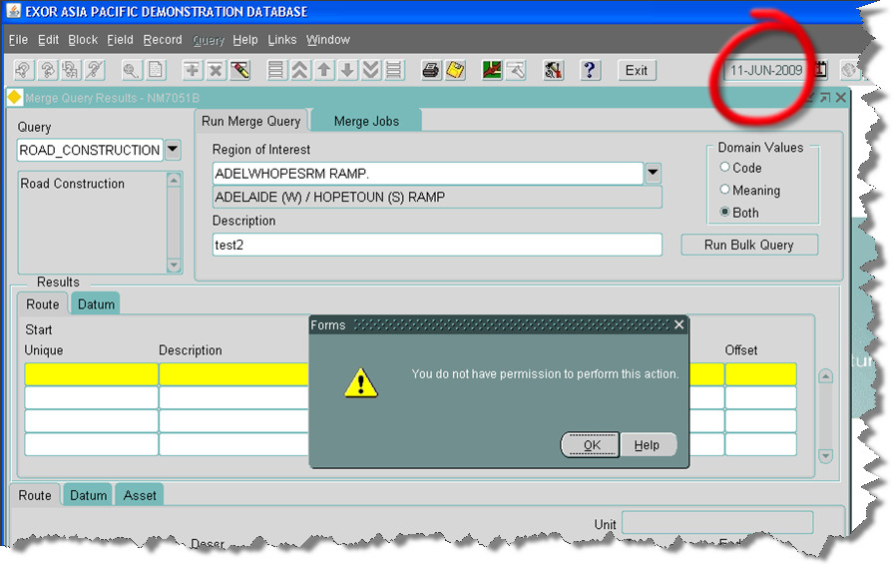

This issue was caused by a failure of the installation procedures of past versions. The installation procedure should create a context through execution of the file <exor_base>\nm3\admin\ctx\nm_sql_context.sql
and although the file was included in the release, its execution was seen to be missing. Corrective action at version 4.0.5.4 is available as fix 35. Release 4.1.0.1 will create the context. Administrators of systems at 4.1.0.0 may wish to execute the file or install version 4.1.0.1.

- Task 0108687 – Primary Key Violation on creation of Asset
Primary key violation on creation of an asset was seen to be due to an extraneous trigger on the view NM_INV_ITEMS. The trigger had originally been built to cast table differences which have now been absorbed into the product. It is now obsolete, performing nothing other than an insert into the base table. Unfortunately, on systems that include Traffic Manager a similar trigger is created to perform validation of traffic sections and count-sites. This trigger also performs inserts into the base table resulting in a primary key violation. The upgrade script of 4.1.0.1 includes the statement to drop the trigger NM_INV_ITEMS_INSTEAD_IU.

- Task 0108681 - Displaying Partial Group Membership
Partial road group indicators were not displayed correctly in Spatial Manager as illustrated below.
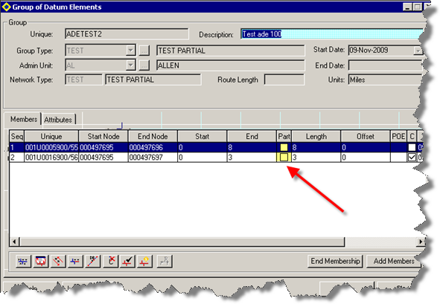
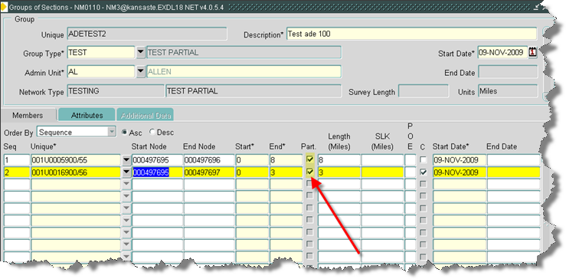

- Task 0108660 Hierarchical Assets
When assets are set up with parent/child/grandchild AT relationships ' adding a second child asset causes error:
NET-0106 ' Cannot locate asset records which are in a child AT relationship.’

This relates to three separate ecdm logs, namely 722948, 720091, 697651.

Code has been changed to allow more than one non-exclusive child assets (with exclusive Parent) with mandatory AT relationship.

- ECDM Log 722941 - Derived asset TSTR fails
Derived asset failure with resultant error message - ORA-00904: "Q"."BEGIN_MP": invalid identifier: nm3eng_dynseg_util.populate_tmp_table(p_mrg_job_id=5683, p_inv_type=TSTR).

- ECDM Log 723304 - Unable to create spatial element
Error in Spatial Manager when attempting to create a new network element whilst snapping to an orphaned node.

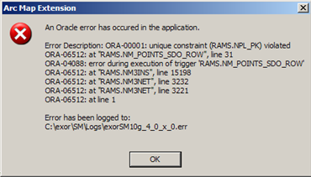

The solution is included in build 6680 or later.
- ECDM Log 722923 - GOS and splitting element
Network element modules such as NM0200, NM0110 and NM0105 are called after the conclusion of the split, merge replace and other similar modules. The called form is called after server changes are posted but not committed. The resultant called form should indicate on exit/query that the changes are not committed and allow the user to save or cancel the changes. Also, the called modules should detect that server changes are outstanding and allow the user to force a commit through the keys or toolbar.

- ECDM Log 723234 – Negative Route Measures
The form nm0122 form has been corrected to allow negative route offsets. Negative values are handled just as positive; messages will be displayed should route offsets fail to translate to a datum reference. Other modules may have similar problems and a review is being conducted. This error also relates network extent creation in SM which is a current problem but is being considered for a future release.

- ECDM Log 723017 - MQ returns invalid dates for 1950 and prior
The merge query results module displayed attribute data in an incorrect format and could convert 2-digit years incorrectly.

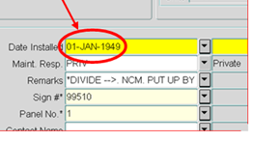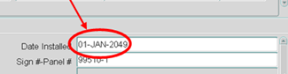

- ECDM Log 723001 - Merge of Datums with Partial Groups
Merging two datums could result in multiple location records to model a contiguous network group member. This fix is also available as 4.0.2.2 Fix 8. This corruption is caused in rare circumstances with a specific configuration of the merge with specific cardinality and order/flip settings. The resultant two members for the same datum results in a unique key violation failure when using the partial road group in the assets on a route module (NM0560).

- Task 0108592 – Merge Query Issue String buffer too small.
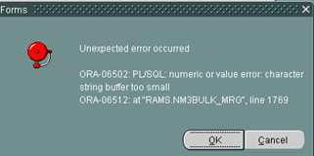

This issue is also fixed inside 4.0.5.4 Fix 36. It relates to ecdm logs 723109 and 722590.

- Task 0108567 – Network groupings
As explained in previous release notes, the integrity of the database could be compromised through invalid data entry in the network groupings modules. This release includes an improved version of NM0004 Group Types module which will perform integrity checks on the group types and their components.

- Task 0108565 – Locator Unpin Problem
A test had identified that when you unpin Locator and drag the left hand edge of the map to expand it, it will expand, but re-centring it results in the map disappearing off the right hand edge of the screen.

- ECDM Log – 720290 – Admin Unit Security and Date Logic
This fix is also available as 4.0.5.4 Fix 29. Although the ecdm log relates to measures on routes, which related to customer data problems, the log also identifies the problem that when locating an asset at a past effective date, the admin unit security would fail to find details of recently created admin units on the same datum.

- Task 0108559 – Highlight Colour in Spatial Manager
Functionality has been added to enable the user to set the selection highlight colour in Spatial Manager.

- Task 0108558 – Redundant layer Creation Buttons
Forms to handle group types and asset types (NM0004 and NM0410) have had redundant buttons removed. The buttons were used as an old method of creating spatial layers.

- ECDM Log 723068 – Locator Map measure tool failure
Also available as nm_4054_fix27, this fix allows the user to measure the length and area of lines drawn in locator on systems that are configured with a spatial co-ordinate system in units other than metres. The current display is returned in metres and the change to display the distance in the original map units will be considered in a future release.

- ECDM Log 722085 - Error creating a defect on asset
The menu tool to create defects at the centroid of a complex, compound polygon was failing as a result of the server code making a corruption to the memory-resident geometry prior to the call to evaluate the centroid. This is also available as 4.0.5.4 Fix 27. The corruption only occurred when using some multi-part polygons and had no impact other than a failure to create the defect.

- Task 0108516 – GRI0200 and PL/SQL numeric or value error
Changes to database fields in recent years had not been correctly followed through to generic core modules such as GRI0200. This module could fail with a PL/SQL numeric or value error depending on the size of data fields.

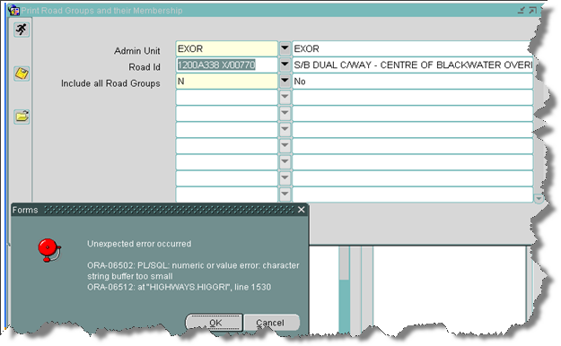

The module is required to work on a huge variety of data fields and now truncates descriptive text where appropriate.

- ECDM Log 714261 - Error modifying colours in STP4400
The inability to set the colours of layers in the STP4400 module was due to the inability to call the colour-palette module HIG1811. The 4.1.0.1 release contains an upgrade script to create the module metadata to correct this problem. By creation of the HIG_MODULE and HIG_MODULE_ROLE record. The HIG_USER role is assigned to this module. If your site does not support the use of HIG_USER role contact support.

An error displayed as ""FRM-41391 Cannot find visual attribute: invalid ID" can be resolved by setting the Visual Attribute in Asset Domain screen (NM0301)"

- ECDM Log 723431 – Error in snapping Defects to Road Network in Locator
The customer complained that Locator could not successfully snap a defect to the network. This particular problem if often due to faulty metadata, usually in the label column of the themes table. This was found to be the case and the data was repaired. However, the problem persisted and was seen to be in the nm3sdo.get_objects_in_buffer function and would result in cases where locator sub-select was not in use, where the theme-table and theme feature table were different and where the nth_feature_fk_column was null.
This is also included in 4.1.0.0 Fix 3.

- Task 0108755 – Off-network Asset Attributes in SM
In cases where an off-network asset has been registered with no spatial history, the theme is configured such that the opening of the attributes form in Spatial Manager could fail with an ORA-00904 error as shown below.
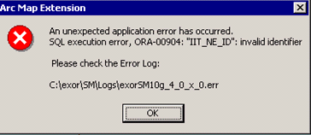

As a workaround it is recommended that the theme be registered with history such that a spatial, date-tracked join view is registered. The extraction of the ordered set of attributes into the form will be successful.

It is proposed that the join view is constructed irrespective of whether the spatial data should be date tracked in a later release.

- ECDM Log 723610 - Display of USRN no in Datum Elements
Spatial Manager could display the USRN number in a scientific notation if the number was large.

- ECDM Log 722924 – Resize Route Not Working
The resize route function has been disabled on some categories of route types. Route types that are deemed to be divided should not be resized in the way in which this code operates. Inside SM the resize route is also prevented on partial element routes – this had already been coded in the forms modules.

- Task 010866 – Validation of Decimal Places on Asset Attributes
This task relates to two issues. The first is 723147and raises the issue that a falure arises during attempts to modify an asset attribute to a number of decimal places greater than that specified in the asset metamodel, In this case, the server validation should round the data. The second is 723575 and this relates to the same problem but driven from the IIT_X and IIT_Y asset attributes of an asset driven by its XY location. The customer in question had a format mask on the XY data and attempts to move/reshape the asset in Spatial Manager resulted in the validation failure. The fix is to prevent failure but allow rounding when the number has too many decimal places but the change also is required in the package that generates the spatial data to keep the oracle geometry data in sync with the asset XY attributes.

- Task 0108833 - SM - X and Y attribute Values Rounded
This also relates to the decimal places formatting of asset attributes including those that drive XY location on assets. Spatial Manager allows the update of the X and Y values. These are now formatted correctly.
- Task 0108836 – Unable to Create Datum Element in Spatial Manager
Under some scenarios of metadata, when the datum element unique key was not being auto-generated, SM would fail to create a datum element.

- Task 0108874 – reshaped polygons or lines disappear or degenerate to a point
This relates to an ecdm log number 724017 which was raised after beta testing of a specific 4054 fix (Fix 37). This fix had been included in the original 4.1.0.1 release. A new fix to replace the obsolete fix 37 will be prepared and the same code added to the 4.1.0.1 release. Hence, in theory, this specific problem will nto be encountered outside of the original beta test environment from which it was raised. The fix was to ensure that the XY co-ordinates of an asset are rounded in the IIT_X and IIT_Y columns according to the metamodel. This had a fault in that lines and polygons were also affected as well as the point assets. This has been corrected.

- Task 0108887 - Get From Map not working at 4100
Further testing of modules in the 4.1.0.1 environment has shown that the get-from-map functions that are embedded into modules such as NSG010 and TMA1000 and DOC0150 failed to return and use the selected ordinates. This affected all modules where a single ordinate pair were expected. The package used behind the locator module has been changed to correct this problem. A further fix will be made available for users of 4.1.0.0 (4.1.0.0 Fix 4 – Task 0108889 )

- Known Issues at 4.1.0.1
- Creation of a user
The addition of a role against a user is no longer a mandatory part of the process of the user creation. The HIG_USER role should be granted to the subordinate user as this will pass on the privileges to access some system dictionary views that are executed inside the user-instantiation trigger. This role is also used to pass on access to the base forms modules such as the launchpad and fastpath.
On creation of the user, if the error/message "Public synonyms not available, you must create private synonyms for this user." Results, then this can mean that synonyms to the two packages (nm3user and nm3context) that are referenced from the instantiate user trigger are missing but it can also mean that the user cannot execute the procedure from the nm3context package due to missing privileges on some dictionary views.

This has been modified in 4.2.0.0 to ensure the role is mandatory.

- Number formats in SM
The VB number format in the grid control used to handle asset and network attributes in Spatial Manager will not handle long format numbers. Free format attributes or those that allow a great many digits will be open to digit loss if numbers such as 1234567890123456789012.12 are entered.

- Failure in creation of an off-network asset layer
The creation of an off-network asset layer can fail if the inventory view has not already been created. Please ensure that the inventory views are established prior to using the layer creation tool. Failure results in an unhandled exception as shown below.

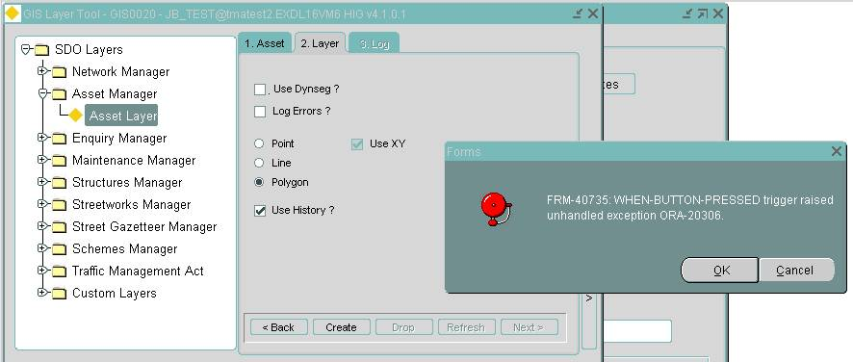

At release 4.2.0.0, the asset view is created during the layer creation so this error should not arise. See task 0108890
- Fixes, Enhancements and Changes at 4.2.0.0
The following are a list of internal task identifiers with associated ecdm fault logs (where appropriate) that have led to changes in the 4.2.0.0 release.

- Task 0108242 - Mixed Case Asset Attributes
A number of customers require asset attributes to be held in either mixed, lower or upper case. This is logged under ecdm numbers 714626 and 715773. This is a requirement that goes back to the first days of NM3 and was originally declined as an option due to difficulty. Server and client tools are much improved and this is now feasible but the impact is quite significant. This includes the following.
NM0410 - Asset Metamodel (The form that allows you to set the case restriction)
NM0105 - Elements
NM0110 - Group of Sections
NM0115 - Group of Groups
NM0116 - Bulk Network Update
NM0510 - Asset Items
NM0511 - Correct Load Errors
NM0512 - Correct Load Errors (MCI)
NM0530 - Global Asset Update
NM0535 - Bulk Asset Update
NM0560 - Assets on a Route
NM0570 - Find Assets
NM0572 - Locator
NM0573 - Asset Grid
NM0590 - Asset Maintenance
NM1100 - Gazetteer
NM7040 - PBI Queries
NM7050 - Merge Query
NM7051(B) - Merge Query Results

The upgrade will set all asset attributes to be UPPER case by default. Query tools such as assets on a route and locator are equipped with case-override tick boxes to allow the user to perform a case insensitive search. Please note that some attributes to foreign tables may be mixed case or lower case and this will affect the behaviour of the search tools. It is beyond the scope of the upgrade to check each foreign table column for existence of mixed or lower case attributes so it is incumbent on the system administrator to reset any attributes that are mixed or lower case. If the attributes are not reset, users will experience a failure to find the specific asset via an attribute query if the case insensitive option remains unset. Some examples of this include the defect location text held in a defects foreign table for use in Maintenance Manager.

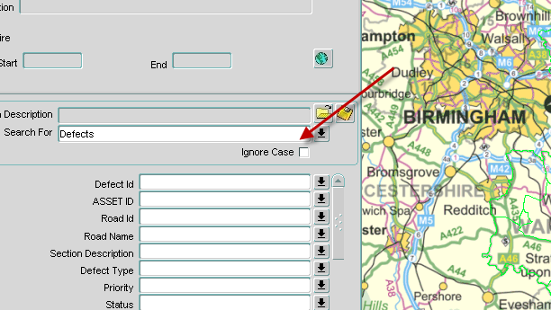

This also affects Spatial Manager.
- Task 0107356 - Forms crash on exiting a form with error FRM-92100
FRM-92100: Your connection to the Server was interrupted.
This may be the result of a network error, or a failure on the Server.
You will need to re-establish your session.
This was found in the work order form MAI3800 in Maintenance Manager but can affect all modules under similar circumstances. It is logged in the ecdm log numbers 715954 and 715206
- Task 0108740 - Multiple themes results in Hig-0150: GIS Theme data is invalid.
This relates to ecdm log 717628 and is due to view based layers such as those representing Defects, Structures, Accidents, PEMs inherit the base table NTH_WHERE_CLAUSE on the theme metadata. Preventing this inheritance prevents the missing column errors when using the Extended LOV during navigation to the specific spatial object in locator.

- Task 0108386 - Locator searches with Null and Not Null predicates
Ecdm log number 722388 has been dealt with by allowing locator to handle predicates such as where an attribute is NULL or NOT NULL.

- Task 0108620 - Resize group is prevented when inappropriate
Resize Group has is prevented on group types which are assumed to be divided highways. The button is now greyed out preventing its use rather than raising an error when executed. This is due to the resize group function allocating new lengths to the datums within the group on a pro-rata change basis. On divided highways, the length is unlikely to be sum total of the datum lengths and the resize would lead to corruption of data. This is a further iteration of ecdm log 722924.
- Task 0108765 - Rounding of decimal places in numeric attributes
This relates to ecdm logs 723575 and 723147. It especially applies to numeric data loaded through exor APIs or set from a mapping tool such as Spatial Manager. It is not recommended that off-network assets spatially represented through the XY values in IIT_X and IIT_Y are rounded. If so, please ensure they are rounded to a number of decimal places that is appropriate for the spatial tolerance in both the Oracle metadata and in any ESRI metadata.

- Task 0108705 - Un-end-dating an asset
Un-end-dating of an asset results in the location remaining end-dated. Location and spatial representations of the asset will be un-end-dated accordingly. This relates to ecdm log 723396.

- Tasks 0108731 and 0108757 – Historical spatial data
Some time ago, the dynamic segmentation of network layers was modified to include all historical locations. The 4.2.0.0 release now includes historical spatial representations of all XY driven data. This relates to ecdm log number 723576. Also, new themes that are created from assets driven through an XY column set is also created as a date-tracked theme. This relates to ecdm log 723576.
- Task 0108789 – HIG_USER Role is mandatory
As mentioned in the list of known issues at 4.1.0.1, the creation of a user without having granted the HIG_USER role will cause difficulties. The form has been amended to force inclusion of the HIG_USER role. Any failures result in a meaningful message and the new user account being locked. There is a re-activate account function available as a recent improvement. It is realised that the HIG_USER role is assigned a great many inappropriate privileges and this will be considered in due course. Original versions of network manager included the HIG_USER role purely for connect and resource privileges as well as the inheritance of shared menu and module data to allow access to modules such as fastpath. Over several years the list has been increased. If the current list of privileges is considered too great please contact exor support. The task relates to the ecdm issue number 723731
- Task 0103787 – query in NM0590 results in FRM-40831:
In form NM0590, querying back assets results in the error "FRM-40831:Truncation occurred value too long for field. The field name (eg -NAR_CHR_ATTRIB74) is also displayed. The display is fine thereafter but the message must be acknowledged several times. This has now been corrected.
- Task 0108303 – Analyze Any Privilege
Performance improvements in the NSG loader require that the statistics on tables into which large volumes of data are being loaded are kept up to date during the load process. The “Analyze Any” privilege will be granted to the HIG_USER and HIG_ADMIN during the upgrade.
- Task 0108723 – refresh NSG spatial Layers
The form GIS0020 has been modified to include the option to refresh the NSG layers, thus retaining themes and related theme metadata.

- Task 0108701 Unhandled exception ORA-20060
This exception could be raised during execution of the module NM0116 Bulk network update. The exception is now handled is now handled with a more meaningful error message. The error relates to null values in a mandatory field and is now reported as such.

- Task 0108674 – Use of public synonym to Spatial metadata
The requirement for a public synonym to MDSYS.SDO_GEOM_METADATA_TABLE is no longer required after its removal from source code. The synonym was created in an earlier release. The upgrade script will nto drop the public synonym as it could be used by other exor highways releases on the same instance. This is unlikely but it is left to the system administrator to review and drop the synonym as required.
- Task 0108566 – Removal of theme creation from forms
Functions to create spatial representations of groups and asset layers is no longer available from the associated metadata forms. Improvements will be made to the generation of foreign table themes by allowing a theme and a foreign table asset type to be created directly. Interfaces to the various metadata checker scripts are also available as are spatial index repair tools.
- Task 0108555 – HIG.PLL ordering utilities
This client library has bene equipped with generic ordering tools to help build more flexible ordering utilities inside forms in future releases.
- Task 0108549 – Highways owner integrity check
The HIG_USERS table is now equipped with a function based index to prevent more than a single highways owner being flagged.
- Task 0108543 – calling Gazetteer results in ORA-6502
The error ORA-6502 can result when double clicking in the road description field of DOC0150. The error results when the description field contains more than 100 characters. This was due to a failure to absorb column length changes in a previous release and has now been corrected. This leads to a full impact assessment of the specific change under the next task.
- Task 0108524 – Impact of column change to NE_DESCR to 254 characters
The full impact analysis was performed to ensure all core modules relating to this field could accept longer column values. Network element description was upgraded to 240 characters and the full impact was not absorbed in several modules. Release 4.2.0.0 now handles the full length of the filed in the modules NM0200, NM0201, NM0202, NM0220 thus avoiding truncation errors.
- Task 0108957 – Correction to Theme Metadata
As part of the ongoing improvement to the reliability of the spatial server, the themes metadata is being updated to provide improved reliability. Specific themes will be updated to correct label column irregularities and some of the erroneous column deficiencies in existing metadata. The repair script will be executed during upgrade and will be available in the release files.
- Task 0108915 – Move of a generic package from the MCI product into core
The package NM3MCP_FTP which had been part of the Mapcapture Interface product has now moved into the core product and has been renamed to NM3FTP. This package provides utilities to interface to FTP servers directly from the Oracle server.
- Task 0108890 – Asset view creation during creation of Off-network-asset layers
This was flagged as a known feature at release 4.1.0.1 and is now corrected. The unhandled exception Ora-20360 when creating an off-network asset layer could result if the administrator had failed to create the asset view. This is corrected by the system creating the view prior to its execution if necessary. Other methods to help create off network and foreign table assets have also been included.
- – Task 0108821 - FRM40202 Field must be entered in NM0510
Failure with Error message "FRM 40202 Field must be entered" during the addition of a subordinate item of a hierarchy in NM0510 has been corrected.
- Task 0108817 – Incorrect version tag reported in form NM0530
This module now displays the correct source control version number.
- Task 0108815 – Error NET-0389 Invalid value….
The error “NET-0389: Invalid value defined for attribute:" being raised when calling the Gazetteer from certain modules and using the wildcard restriction on element Unique and/or Description has been corrected.
- Task 0108802 – Resize route button is greyed out.
The prevention of operation of the resize route in specific circumstances had already been dealt with in a previous patch. The 4.2.0.0 release includes the minor change of having the button to resize the route greyed out and made unavailable.
- Task 0108477 – Web utilities
The core product is equipped with utilities to better handle file transfer and storage to those with a full infrastructure tier in the app server. These tools will be utilised in future releases to improve file uploads and to improve document manager storage and usability. These methods will render the DAD methods obsolete in due course.
- Task 0108354 – Module HIG1901 has increased size of Username in LOV
Hig1901 has an improved field length in the username LOV
- Task 0108212 – Use of CTRL-Q to cancel query in NM0510
The use of CTRL-Q to cancel the query in module NM0510 forced the form to close. This has been repaired.

- Addendum to pre-release document version 1.0
As mentioned in the introduction, the list of tasks and ecdm log numbers that have been included in the release notes differs from that published in the pre-release preview of this document. There have been many additions to the list but there were also several omissions that failed to be included for a variety of reasons. Those published in the preview and not included in the release are listed below.

- Task 0108209 – Errors with effective data in NM0560
This is not related to an ecdm log but results from attempts to set the user effective date during the location of the asset. This is not recommended.

- Task 0108283 – Order of defects created in Locator.
When creating sequential multiple defects in spatial locator along a path, the order is being skewed incorrectly. This forces the user to create defects one at a time. This relates to ecdm log number 722115.

- Task 0108568 – Displayed Units in MapViewer
The units in Mapviewer when displaying data from the Spatial Server are assumed to be Meters. Customerssometimes use other units and although the data is accurate and translated to units, mapviewer must be changed to use the units of the spatial data or default to a preferred unit.

- Task 0108908 – Intersection Modelling
Safety product and generic requirements for the network model mean that there is a need to model intersections as a partial road group and have them treated as a prime entity for location of events directly at an intersection or indirectly as a route reference past an intersection.

